Voyage Analytics – Integrating MLOps in Travel
Submitted By – Premsagar Palled
GitHub Link - https://github.com/prem1555/Integrating_MLOps_in_Travel_Productionization_of_ML_Systems/tree/main

1. Project Title Voyage Analytics – Integrating MLOps in Travel

2. Project Overview
Voyage Analytics is an end-to-end MLOps-based travel analytics system designed to automate machine learning workflows and provide intelligent travel-related predictions and recommendations.
The project integrates:
- Machine Learning Models
- Flask REST APIs
- Streamlit Dashboard
- Docker Containerization
- Kubernetes Deployment
- Apache Airflow Automation
- Jenkins CI/CD Pipeline
- MLflow Experiment Tracking
The system utilizes travel datasets containing user, flight, and hotel information to:
- Predict flight prices
- Predict user gender
- Recommend hotels
- Automate ML workflows
- Deploy scalable ML services

3. Business Problem
In the travel and tourism industry, large volumes of user, hotel, and flight data are generated daily. Businesses need intelligent systems that can:
- Predict flight prices accurately
- Understand user demographics
- Recommend hotels based on preferences
- Automate retraining and deployment workflows
- Deploy scalable machine learning applications Traditional systems often lack:
- automation
- scalability
- deployment consistency
- workflow orchestration
This project solves these challenges using MLOps principles.

4. Project Objectives
The main objectives of the project are:
- Build a regression model for flight price prediction.
- Build a classification model for gender prediction.
- Build a recommendation system for hotel suggestions.
- Develop REST APIs using Flask.
- Containerize applications using Docker.
- Deploy applications using Kubernetes.
- Automate workflows using Apache Airflow.
- Track experiments using MLflow.
- Implement CI/CD using Jenkins.
- Build an interactive Streamlit dashboard.

5. Technologies Used
Technology Purpose

Python Programming Language
Technology Purpose

Pandas | Data Processing
NumPy | Numerical Computation
Scikit-learn | Machine Learning
Flask | REST API Development
Streamlit | Dashboard Development
Docker | Containerization
Kubernetes | Container Orchestration
Apache Airflow | Workflow Automation
Jenkins | CI/CD Automation
MLflow | Experiment Tracking
Git & GitHub | Version Control
Postman | API Testing

6. Dataset Description

6.1 Users Dataset
Contains user demographic details.
Column Description

code User identifier company Associated company name User name
gender Gender
age Age

6.2 Flights Dataset
Contains flight booking details.
Column Description

travel Code Travel identifier user Code User identifier
from Source location to Destination location Column Description

flightType Flight class
price | Flight price
time | Travel duration
distance | Flight distance
agency | Airline agency
date | Booking date

6.3 Hotels Dataset
Contains hotel booking information.
Column Description

travel Code Travel identifier user Code User identifier
name | Hotel name
place | Hotel location
days | Stay duration
price | Price per day
total | Total booking cost
date | Booking date

7. Project Architecture
Users
↓
Streamlit Dashboard
↓
Flask REST API
↓
Machine Learning Models
↓
Docker Container
↓ Kubernetes Cluster
↓
Airflow Automation
↓
Jenkins CI/CD Pipeline

8. Project Folder Structure
VoyageAnalytics/
│
├── api/
├── airflow/
├── classification_model/
├── data/
├── jenkins/
├── kubernetes/
├── models/
├── notebooks/
├── recommendation_model/
├── regression_model/
├── streamlit_app/
├── Dockerfile ├── docker-compose.yml
├── requirements.txt
├── README.md

9. Data Preprocessing
The following preprocessing steps were performed:
- Removed duplicate records
- Handled missing values
- Converted date columns
- Extracted year, month, and day features
- Encoded categorical variables using LabelEncoder
- Split datasets into training and testing sets

10. Exploratory Data Analysis (EDA)
The following visualizations were created:
- Flight price distribution
- Flight type analysis
- Top airline agencies
- Most common destinations
- Gender distribution
- Age distribution
- Hotel price distribution
- Popular hotel locations
- Correlation heatmaps

SCREENSHOT SECTION

Screenshot 1 – Flight Price Distribution
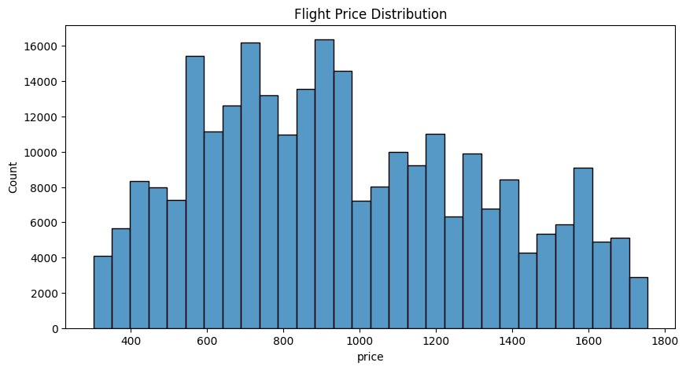

Screenshot 2 Flight Type Count
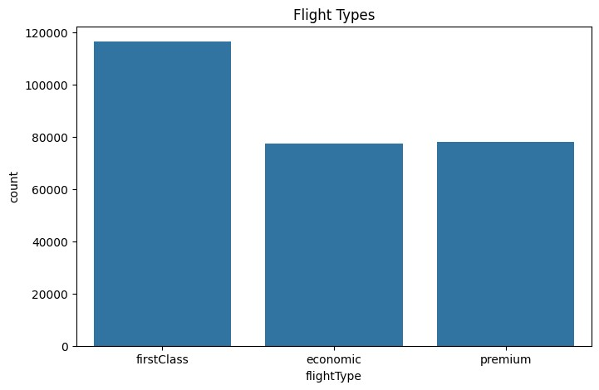

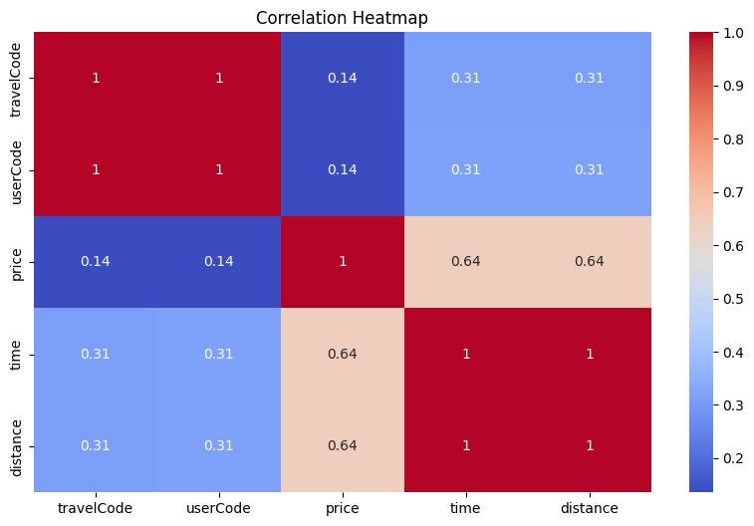

Screenshot 3
–

Correlation Heatmap

Screenshot 4 Gender Distribution
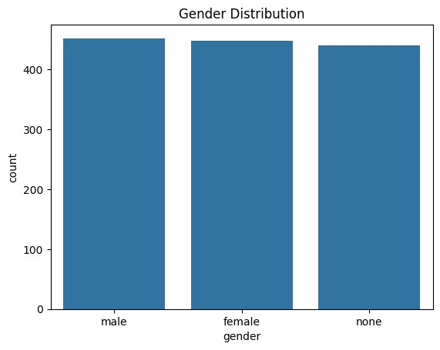

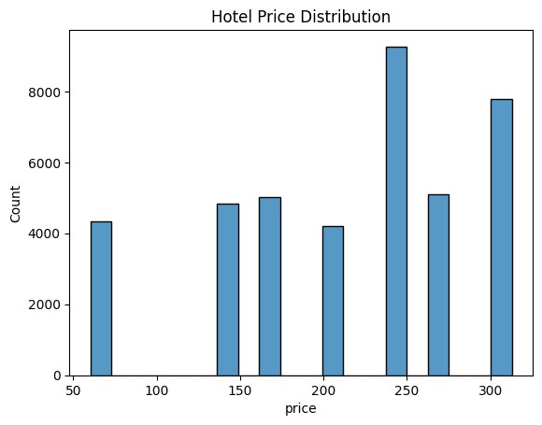

Screenshot 5
Hotel Price Distribution

11. Regression Model – Flight Price Prediction

Objective
Predict flight prices based on:
- distance
- time
- flight type
- agency
- source and destination Model Used
RandomForestRegressor

Features Used
- from
- to
- distance
- time
- agency
- flightType
- year
- month
- day

Evaluation Metrics
- MAE
- MSE
- R2 Score

SCREENSHOT SECTION

Screenshot 6 – Regression Metrics Output
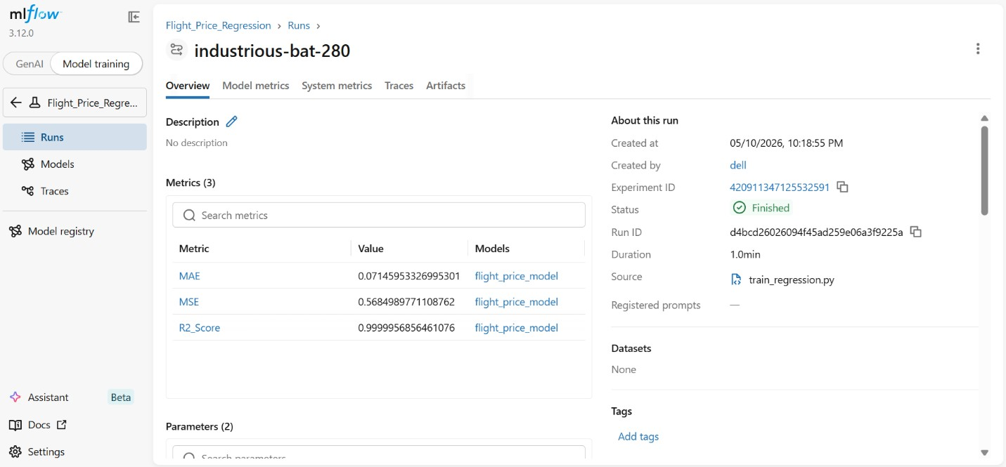

12. Classification Model – Gender Prediction

Objective
Predict user gender using:
- company
- age
- name

Model Used
RandomForestClassifier Evaluation Metrics
- Accuracy
- Precision
- Recall
- F1 Score
- Confusion Matrix

SCREENSHOT SECTION

Screenshot 9 – Classification Metrics Output
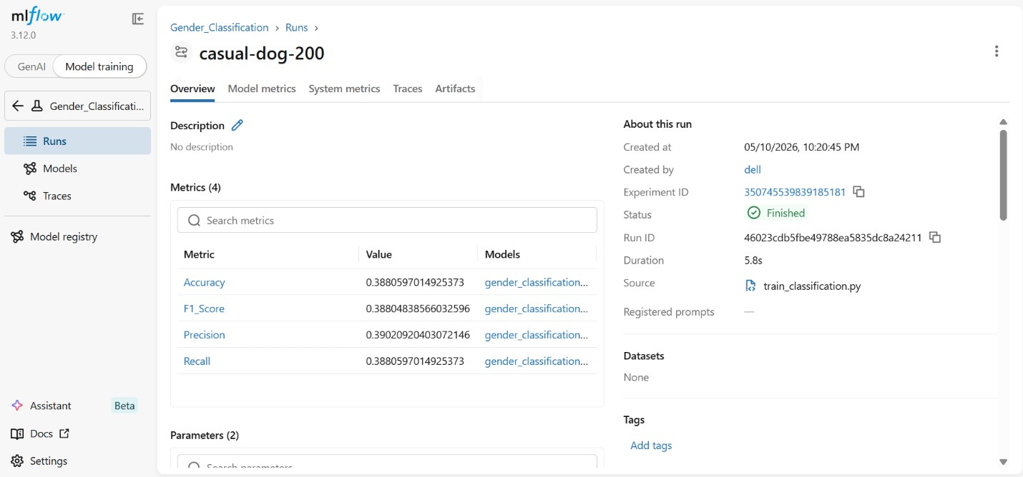

13. Recommendation System
Objective
Recommend hotels based on user preferences and hotel similarity.

Technique Used
Content-Based Recommendation System Algorithm Used
- CountVectorizer
- Cosine Similarity

Features Used
- hotel name
- place
- stay duration
- price

14. MLflow Integration
MLflow was used for:
- experiment tracking
- parameter logging
- metric logging
- model versioning Logged Parameters
- number of estimators

• random state Logged Metrics
- MAE
- MSE
- R2 Score
- Accuracy
- Precision
- Recall
- F1 Score

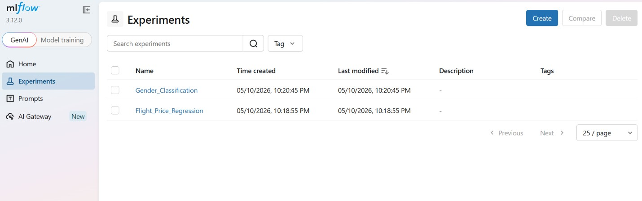

SCREENSHOT SECTION

Screenshot 13
–

MLflow Dashboard

15
. Flask REST API

APIs Developed
Endpoint Purpose

/ Home route
/predict-flight-price Flight prediction
/predict-gender Gender prediction
/recommend-hotels Hotel recommendation Features
- JSON-based API responses
- Real-time predictions
- Recommendation support
- API testing through Postman

SCREENSHOT SECTION
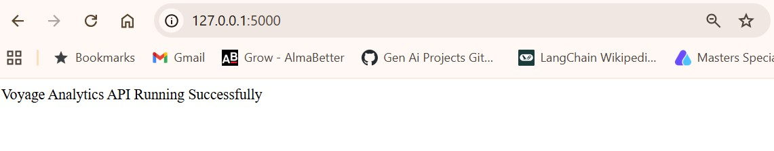

Screenshot 15
–

Flask API Running

16. Streamlit Dashboard

Features Included
- Project Overview
- Flight Price Prediction
- Gender Prediction
- Hotel Recommendation
- Visualizations

Benefits
- Interactive UI
- User-friendly interface
- Real-time API integration

SCREENSHOT SECTION
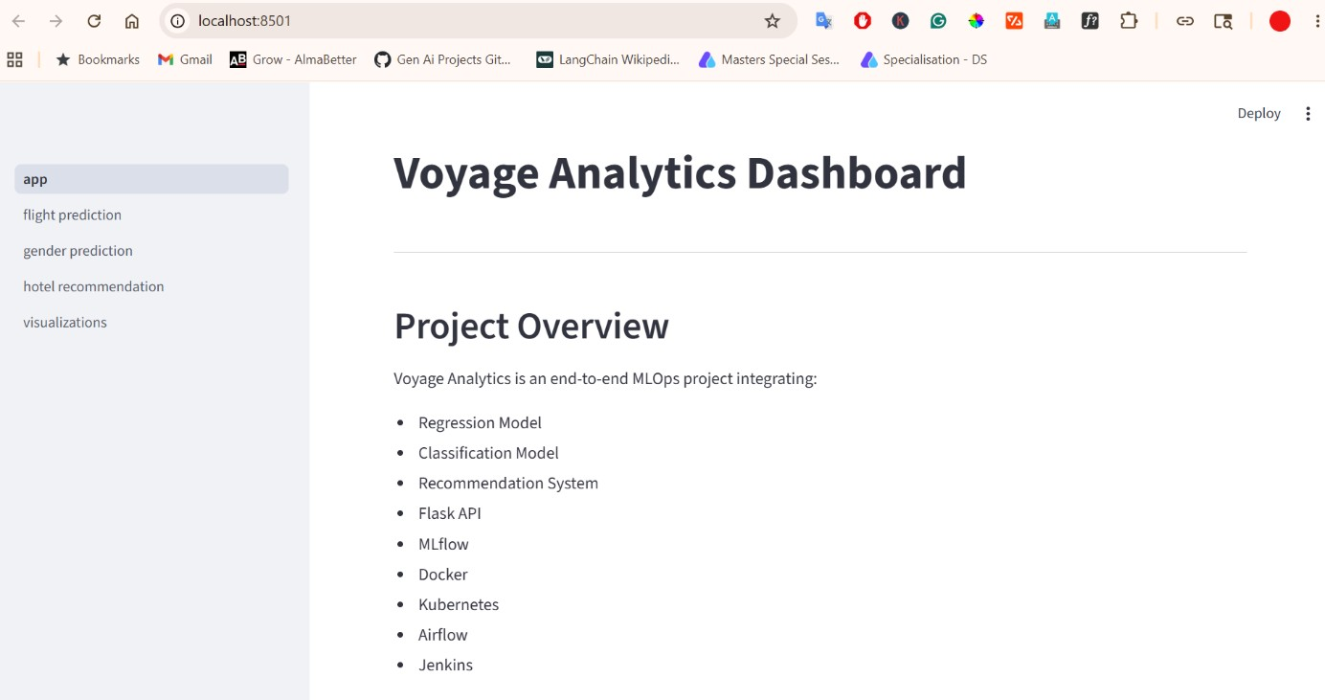

Screenshot 19
–

Streamlit Home Page

Screenshot 20 – Flight Prediction Page
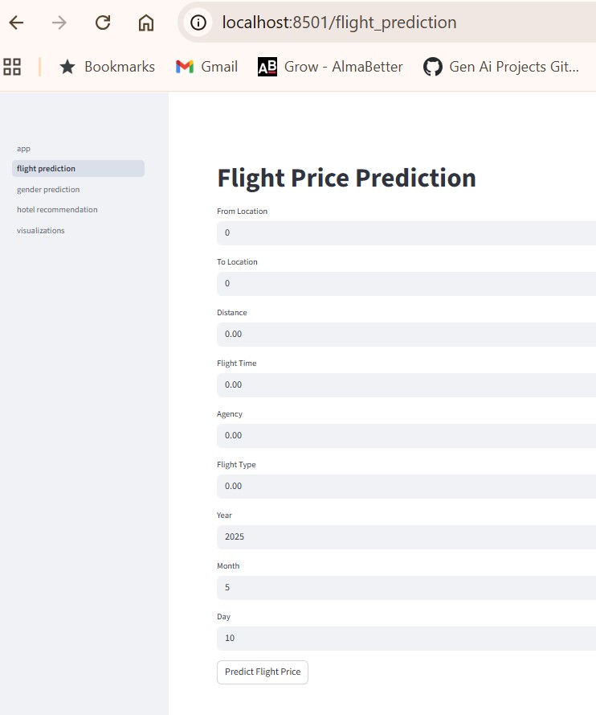

Screenshot 21 – Gender Prediction Page
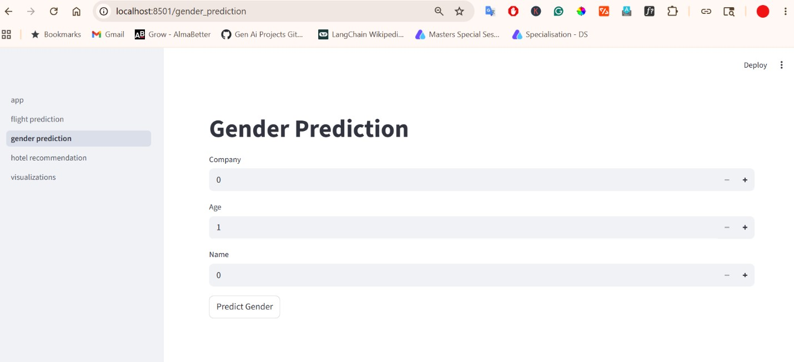

17
. Docker Containerization

Docker was used to package the Flask API and dependencies into a portable container.

Docker Components
- Dockerfile
- docker-compose.yml
- DockerHub image

Benefits
- portability
- consistency
- deployment simplicity

SCREENSHOT SECTION
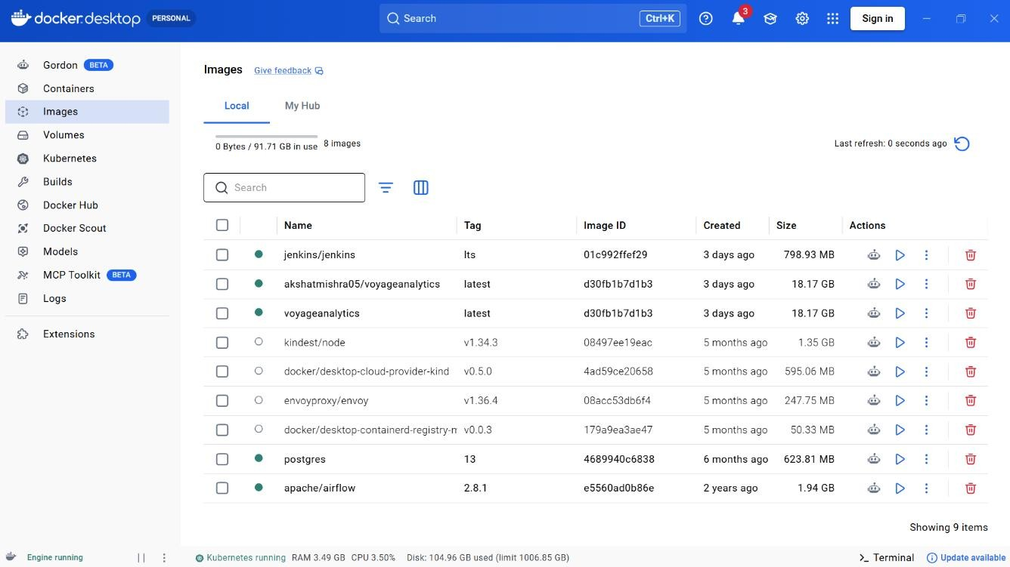

Screenshot 23
–

Docker Image
s

Screenshot 25 – DockerHub Repository

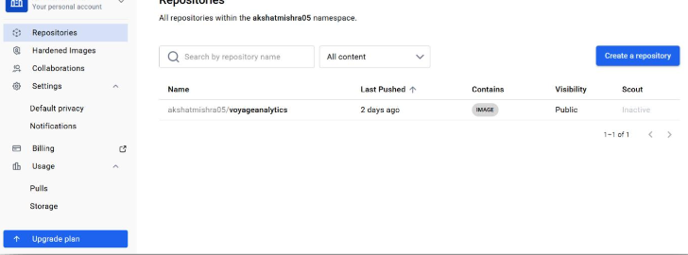
0.

18. Kubernetes Deployment
Kubernetes was used for:
- deployment management
- scaling
- load balancing

• orchestration Kubernetes Files
- deployment.yaml
- service.yaml

Features
- multiple replicas
- service exposure
- scalable deployment

SCREENSHOT SECTION

Screenshot 26 – Kubernetes Pods, Service & Deployment
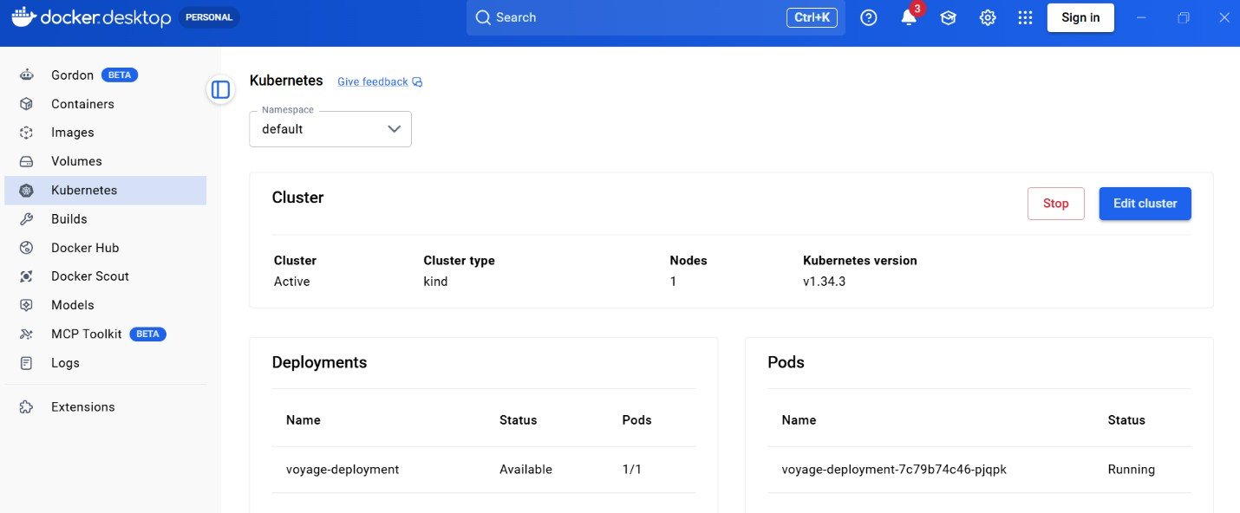

19. Apache Airflow Integration
Apache Airflow was used for workflow orchestration.

Workflow Tasks
- preprocess data
- train regression model
- evaluate regression model
- train classification model

DAG Features
- automated execution
- workflow dependency management
- scheduling support

SCREENSHOT SECTION

Screenshot 29 – Airflow Dashboard, DAG Graph
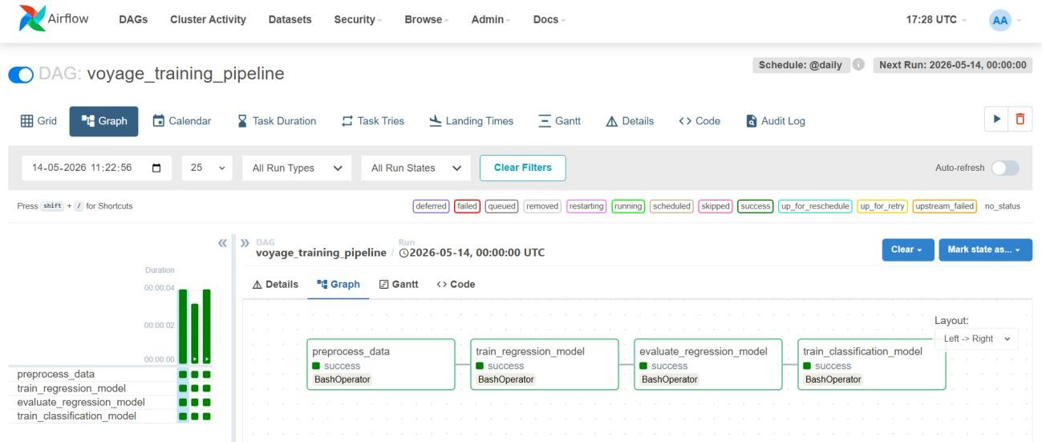

20. Jenkins CI/CD Pipeline
Jenkins was used for:
- continuous integration • automated builds
- Docker image creation
- deployment automation

Pipeline Stages
- Clone Repository
- Install Dependencies
- Run Training Scripts
- Build Docker Image

SCREENSHOT SECTION

Screenshot 32 – Jenkins Dashboard, Successful Pipeline
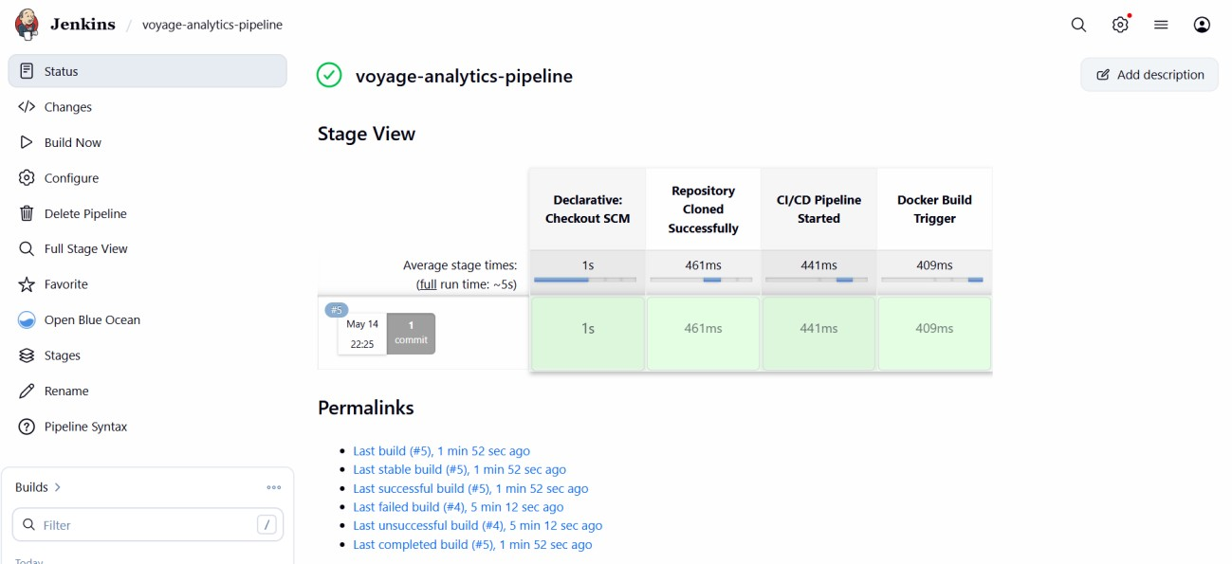

Screenshot 34 – Jenkins Console Output
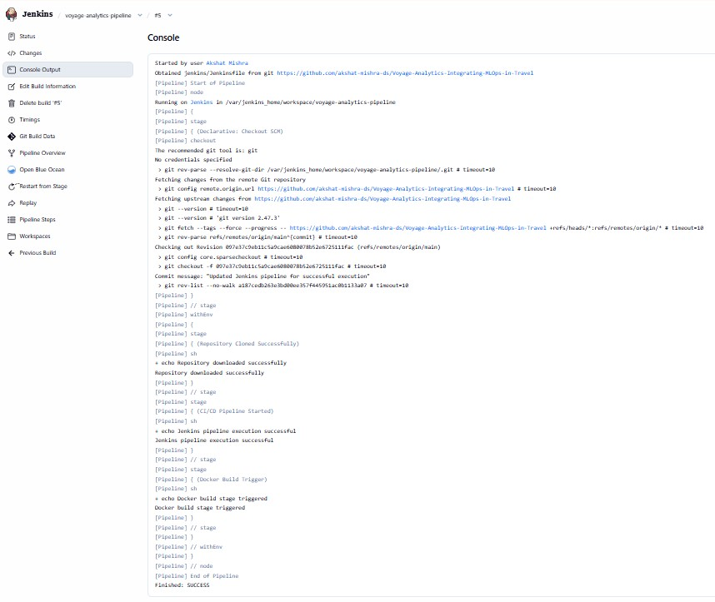

21
. Challenges Faced

Challenge Solution

Import path issues | Executed project from root folder
Kubernetes image pull issues | Used DockerHub image
Flask import errors | Fixed module paths
Airflow setup complexity | Used Docker-based Airflow setup

22. Key Learnings
During this project the following skills were learned:
- end-to-end MLOps workflow
- model deployment
- Docker containerization
- Kubernetes orchestration
- workflow automation
- CI/CD pipelines
- API development
- recommendation systems
- MLflow tracking

23. Future Improvements
Future enhancements can include:
- cloud deployment on AWS/GCP/Azure
- database integration
- authentication system
- advanced recommendation algorithms
- model monitoring dashboards
- automated retraining
- FastAPI implementation
- deep learning models

24. Conclusion
Voyage Analytics successfully demonstrates the integration of machine learning and MLOps technologies into a unified travel analytics platform.
The project achieved:
- predictive analytics
- recommendation capabilities
- workflow automation
- scalable deployment
- CI/CD automation
- container orchestration
This project provides a strong foundation for real-world production-grade machine learning systems.

25. References
- Python Documentation
- Scikit-learn Documentation
- Flask Documentation
- Streamlit Documentation
- Docker Documentation
- Kubernetes Documentation
- Apache Airflow Documentation
- Jenkins Documentation
- MLflow Documentation

